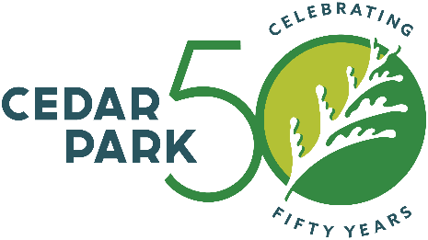

FOR IMMEDIATE RELEASE

Date: September 27, 2023

Contact: Fran Irwin, Director Community Affairs

E-mail: fran.irwin@cedarparktexas.gov

Phone: 512-608-3943

Cedar Park Economic Development and Tourism Department Receives 2023 Silver Award for Economic Development Organization of the Year

Cedar Park, Texas – The Cedar Park Economic Development and Tourism Department received a 2023 Excellence in Economic Development Silver Award from the International Economic Development Council (IEDC). The award was bestowed specifically for the organization’s work in the Economic Development Organization of the Year category. Economic Development Director, Ben White and Assistant Economic Development Director, Scott Smith were acknowledged and honored at the IEDC 2023 Annual Conference during the inaugural Recognition Night event in Dallas, TX, on September 19, 2023.

"The Cedar Park Economic Development and Tourism Department has raised the bar for excellence in economic development. This award is a testament to the Cedar Park Economic Development and Tourism Department’s dedication to its residents and serves as a great example of how economic development can help transform a community for the better," said Nathan Ohle, IEDC President and CEO. “It is IEDC’s honor and privilege to present the Cedar Park Economic Development and Tourism Department with this award and recognize its leadership and innovation in the field of economic development!”

Every year IEDC looks specifically for economic development organizations, government entities, initiatives, and programs that have demonstrated consistent, exemplary performance in the economic development profession, leading the execution of projects that have a significant impact on revitalizing communities and playing a major role in shaping and improving the practice of economic development.

“This award demonstrates the excellence of our economic development program for our citizens. We are honored to be recognized by the IEDC,” said Ben White, Cedar Park Economic Development Director.

About the International Economic Development Council
The International Economic Development Council (IEDC) is a non-profit, non-partisan membership organization serving economic developers. With more than 4,300 members, IEDC is the largest organization of its kind. Economic developers promote economic well-being and quality of life for their communities by creating, retaining, and expanding jobs that facilitate growth, enhance wealth, and provide a stable tax base. From public to private, rural to urban, and local to international, IEDC’s members engage in the full range of economic development practices. Given the breadth of economic development work, our members are employed in various settings, including local, state, provincial, and federal governments, public-private partnerships, chambers of commerce, universities, and a variety of other institutions. When we succeed, our members create high-quality jobs, develop vibrant communities, and improve the quality of life in their regions. Learn more at iedconline.org.
###

